Query MongoDB Atlas

# Step 0: Login into MongoDB compass with your connection string

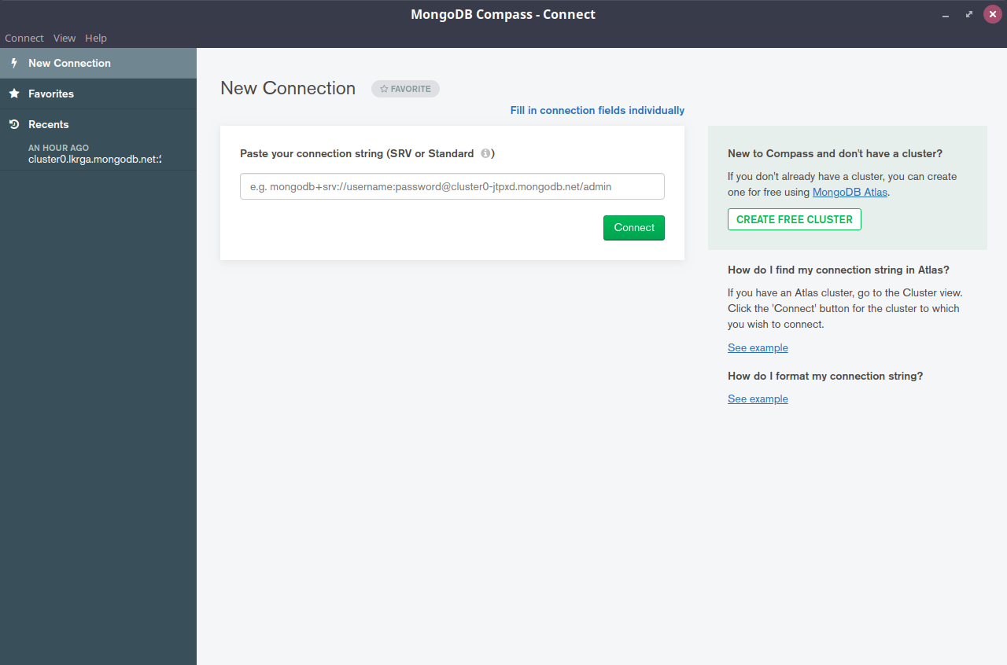

Once you connect to your server succesfully you can see like this

Notice: You don’t need to have a database or any collection exsited

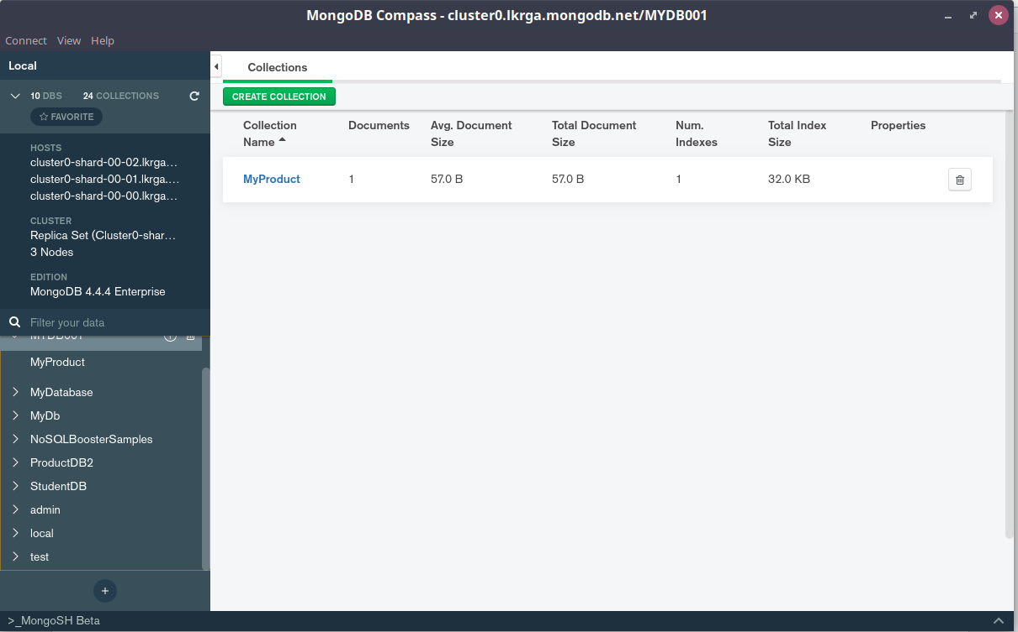

Click here

# Run each command one by one and see the result

//1

use ProductDB2

//2

db.products.drop()

db.products.insertMany([

{productName: 'ipad',price:200,ImportedDate:new Date("2020-08-16"),color:'blue'} ,

{productName: 'IMac',price:800,ImportedDate:new Date("2020-07-12"),color:'red'},

{productName: 'SS galaxy',price:122,ImportedDate:new Date("2020-08-7"),color:'blue'},

{productName: 'Mouse',price:12,ImportedDate:new Date("2020-4-1"),color:'gray'},

{productName: 'Backpack',price:20,ImportedDate:new Date("2020-9-16"),color:'blue'}

])

db.products.find()

//3

db.products.find({color:'blue'})

//4

db.products.find({price :{$gt:300, $lt:6000}})

//5

db.products.find({price :{$gt:30, $lt:6000}}).sort({price:-1})

//6

db.products.updateMany({},{$inc:{price:20}})

//7

db.products.remove({price: {$lt: 300}})

//8

db.products.aggregate([

{$project: {productName:1,price:1,m :{$month: '$ImportedDate'}}},

{$match: {m:8}}

])

# Another way is much easier is to use NoSQLBooster to run the above query

